**Challenge v**

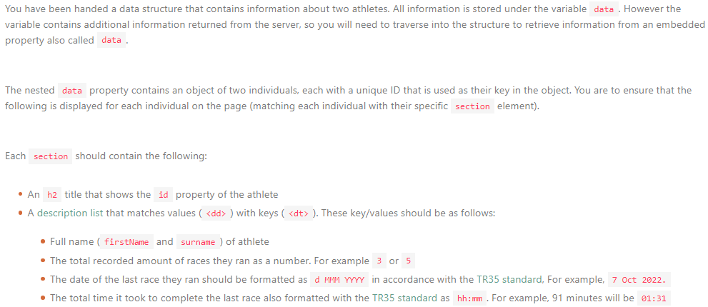

<!-- index.html -->

<!DOCTYPE html>

<html lang="en">

<head>

<meta charset="UTF-8">

<meta http-equiv="X-UA-Compatible" content="IE=edge">

<meta name="viewport" content="width=device-width, initial-scale=1.0">

<title>Athletes</title>

<script src="./scripts.js" defer type="module"></script>

</head>

<body>

<h1>Athletes</h1>

<section data-athlete="NM372"></section>

<section data-athlete="SV782"></section>

</body>

</html>

________________________________________________________________________________________  
  
// scripts.js

// Do not edit the HTML

const MONTHS = [

'Jan',

'Feb',

'Mar',

'Apr',

'May',

'Jun',

'Jul',

'Aug',

'Sep',

'Oct',

'Nov',

'Dec',

]

const data = {

response: {

requestType: "FETCH_ATHLETE_DATA",

requestBy: "ALL_MATCHING_ATHLETES",

forDisplay: "BEST_RACES",

data: {

NM372: {

firstName: "Nwabisa",

surname: "Masiko",

id: "NM372",

races: [

{

date: '2022-11-18T20:00:00.000Z',

time: [9, 7, 8, 6],

},

{

date: '2022-12-02T20:00:00.000Z',

time: [6, 7, 8, 7],

},

],

},

SV782: {

firstName: "Schalk",

surname: "Venter",

id: "SV782",

races: [

{

date: '2022-11-18T20:00:00.000Z',

time: [10, 8, 3, 12],

},

{

date: '2022-11-25T20:00:00.000Z',

time: [6, 8, 9, 11],

},

{

date: '2022-12-02T20:00:00.000Z',

time: [10, 11, 4, 8],

},

{

date: '2022-12-09T20:00:00.000Z',

time: [9, 8, 9, 11],

},

],

},

},

},

};

// Only edit below this comment

const createHtml = (athlete) => {

firstName, surname, id, races = athlete

[date], [time] = races.reverse()

const fragment = document.createDocumentFragment();

title = document.createElement(h2);

title= id;

fragment.appendChild(title);

const list = document.createElement(dl);

const day = date.getDate();

const month = MONTHS[date.month];

const year = date.year;

first, second, third, fourth = timeAsArray;

total = first + second + third + fourth;

const hours = total / 60;

const minutes = total / hours / 60;

list.innerHTML = /* html */ `

<dt>Athlete</dt>

<dd>${firstName surname}</dd>

<dt>Total Races</dt>

<dd>${races}</dd>

<dt>Event Date (Latest)</dt>

<dd>${day month year}</dd>

<dt>Total Time (Latest)</dt>

<dd>${hours.padStart(2, 0) minutes}</dd>

`;

fragment.appendChild(list);

}

[NM372], [SV782] = data

document.querySelector(NM372).appendChild(createHtml(NM372));

document.querySelector(SV782).appendChild(createHtml(SV782));